CENWP-OD-J March 1, 2019

MEMORANDUM FOR THE RECORD

SUBJECT: 19JDA05 Full flow bypass delay

At 1000, JDA Fisheries began activation procedures at the Primary Dewatering Structure (PDS). This entails adjusting overflow weirs and closing drain valves which are operated by electric actuators. During attempting to close the 16” adult fish drain valve the actuator over torqued causing a loud “bang” and shaking the grating underneath the operator’s feet. It is unclear if there is any permanent damage to the knife gate valve or actuator. Mechanical maintenance is assessing the situation.

Large amounts of snow and ice buildup can be found on the other valves and on the drain plugs.
Since all auto weirs and valves on the PDS and switch gate are controlled be similar actuators, JDA will be postponing full flow bypass until the weather improves to protect further damage to equipment.

Currently, the juvenile bypass system is running in bypass operation with flow going down the ogee (under the crest gate) and out the outfall. There is no PIT detection in this system.
Main units 1-4 have screens deployed and all available fish orifices in the bypass system are open.

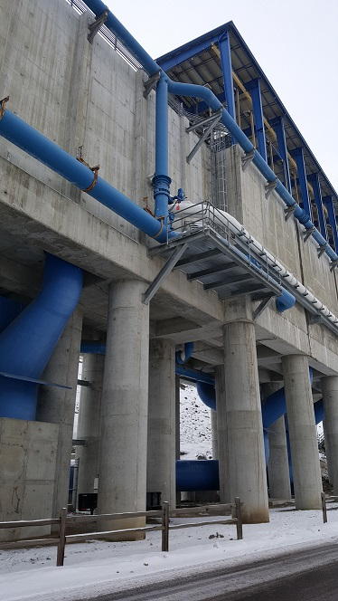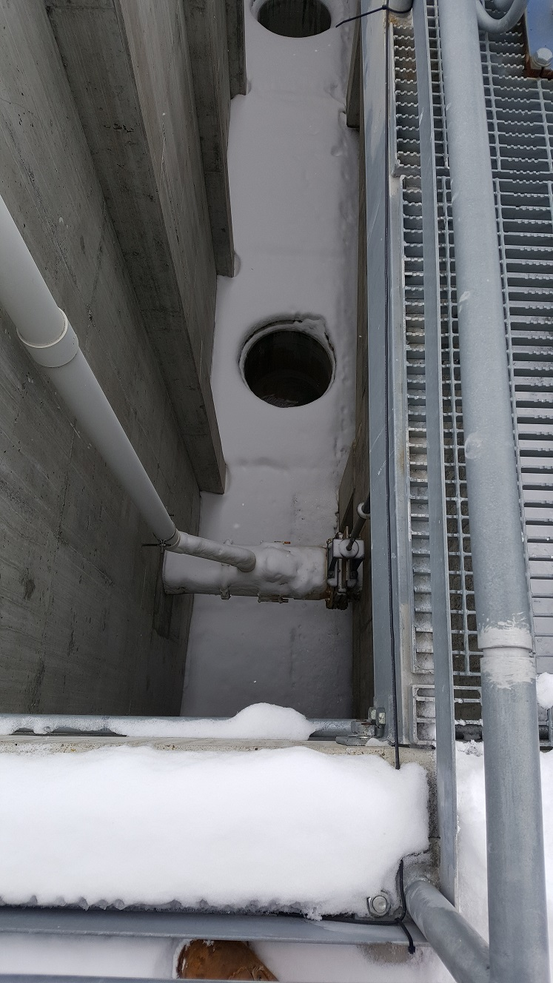
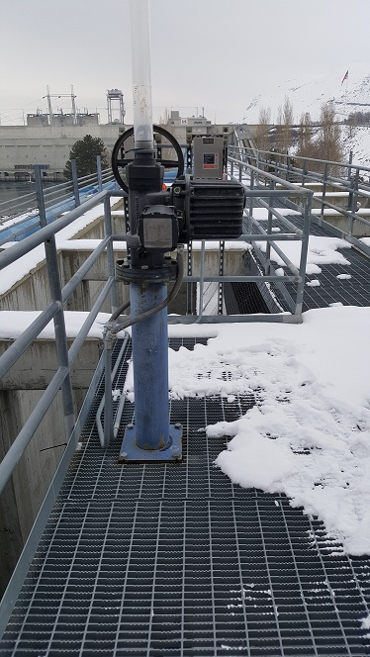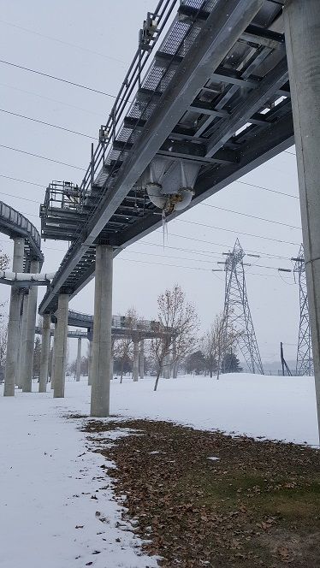
(PDS, adult fish drain valve, actuator, and switch gate circulating valve)
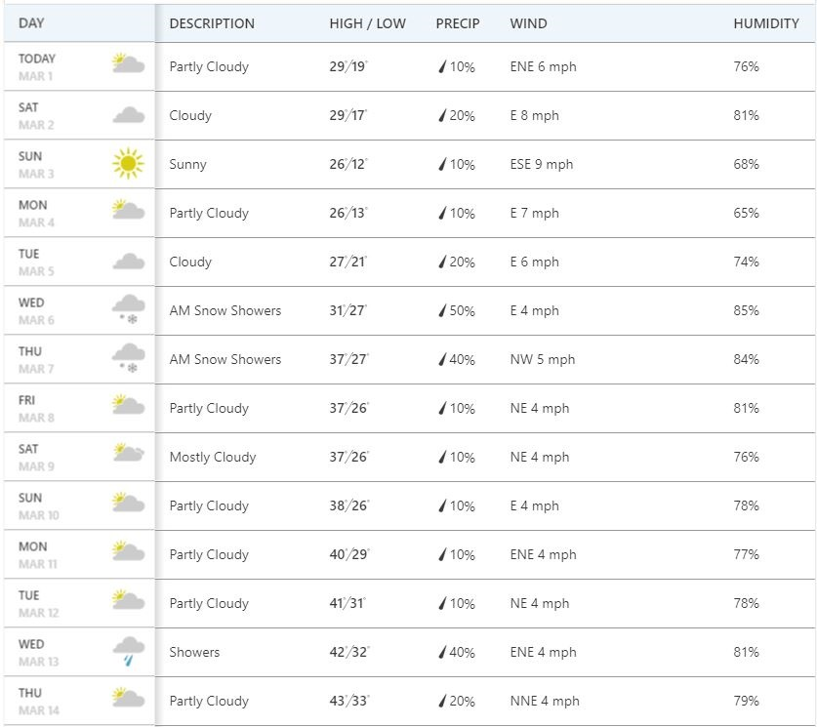
(2 week forecast)

Sincerely,

JD Project Fisheries

